|  |
| --- |
| Microsoft HoloLens: Harnessing Mixed Reality |
| Innovation & Disruptive Technologies, R&D |

  

*Mixed reality, such as Microsofts’ HoloLens, provides users the ability to engage and interact with design data more intuitively.*

Background

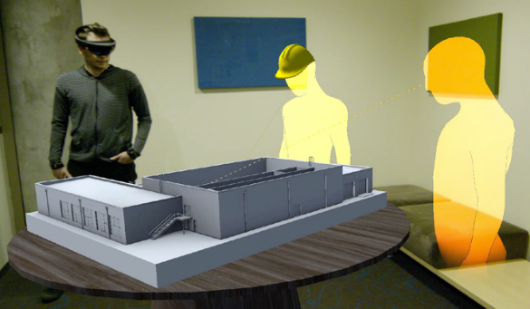Within the architectural, engineering and construction (AEC) industry, new technologies such as “Mixed Reality” signify a new working environment, where architectural design collides with reality, and construction teams transform digital content into physical objects. At CDM Smith, we’re harnessing the power of Microsoft’s HoloLens, a mixed reality technology, to help our clients design, build and operate their infrastructure assets faster and more efficiently. HoloLens is a wearable, self-contained holographic computer featuring a see-through display with advanced sensors that enables users to interact with a blend of the physical environment and 3D holograms. In this mixed reality environment, users can “pin” holograms to physical objects and interact with data using gesture, gaze and voice commands.

Key Team Members:

Scott Aldridge

Matt Harraka

Using HoloLens is very easy and gives you the ability to interact with holograms in the real world around you. HoloLens takes just a few minutes to learn how to operate.

Project Status and Findings

While the AEC industry has vastly improved by transitioning from 2D documents to 3D models, we’re still confined to viewing them on a 2D screen. Mixed reality and holographic technology brings models out of the two-dimensional computer screen and allows users to engage and interact with design data more intuitively. Using mixed reality, stakeholders can walk around and explore a design in fully three dimensions, without the need for an expert to guide them.

CDM Smith is an early adopter of this technology and has been working with a developer called Object Theory to customize HoloLens for applications specific to our industry with funding and support from both our internal Innovation & Disruptive Technologies and Research & Development programs. Because of our partnership with Object Theory, we are one of the first AEC companies to have received the HoloLens device, as the first round of distribution was limited to developers. CDM Smith has built several custom features to optimize the HoloLens experience for both our staff and clients. Our mixed-reality- collaboration applications allow our HoloLens users to collaborate in real time from remote locations, enabled by life size 3D avatars.

How will Project Results Apply to Our Clients’ Needs?

Mixed reality experiences will almost assuredly empower the next generation of collaboration in the AEC industry, going far beyond what today’s video conferencing and screen sharing solutions are able to provide. Using this mixed reality technology, our clients can improve communication between dispersed teams, regardless of their location. It enables efficient viewing and discussion of the same 3D models as if everyone is in the same place.

Additionally, in every construction project there is a decisive process in which design is transformed into reality and abstract ideas are translated into physical objects. The current translation process of turning design documents into reality is a constant struggle, in which wrong interpretation of data often leads to costly errors, quality issues and rework. Digital 3D models reduce the level of abstraction and help clarify the design intent. Because mixed reality technology allows for virtual information to be superimposed on the actual physical environment, users can visualize a design in context, and can better understand, interact with and execute required modifications in real time. For example, if visual inspection in the mixed reality environment reveals that a pipe is too big for its originally designed destination, the designer can make the necessary adjustments then and there using the HoloLens gesture commands, immediately allowing for review of any other impacts to the design within the model. Groups of users can view the same designs at the same time, and the HoloLens not only allows users to see others in the groups via avatars that mimic the users’ movements, but also to view the object of each user’s gaze.

Mixed reality presents the opportunity to create an infinite environment, in which additional data such as schedule, specs and simulation can be overlaid onto the 3D model. The abilities to integrate digital and physical content and present data in context will improve communication and leverage confidence in decision making. CDM Smith’s R&D program is helping our design teams learn this exciting new technology and is providing opportunities for collaboration with software developers to create new procedures for integrating mixed reality into our design in every stage of the design process.