Caring for Our Coastal Waters Through Integrated Stormwater Management
Michael F. Schmidt, P.E., BCEE¹*

¹CDM Smith, Jacksonville, Florida
*Email: SchmidtMF@cdmsmith.com

ABSTRACT
Coastal waters provide food, habitat, navigation, recreation, and aesthetic beauty. For these reasons, many of the largest and most populous cities in the world lie along coastlines, and healthy, productive, and sustainable coastal waters are key to public health, safety, and prosperity.
Coastal waters receive stormwater and wastewater discharges from tributary watersheds across the world, and many coastal waters and systems are experiencing issues with the following:
- Excess levels of nutrients, sediments, bacteria, and freshwater discharges
- Low dissolved oxygen and anoxic zones
- Declining health of flora and fauna
- Legacy sediments
- Accidents such as oil and chemical spills
Super-imposed on these challenges are issues with climate change and associated sea level rise and shifts in precipitation patterns. In particular, sea level rise is leading many coastal communities to armor shorelines as a first step in an adaptive or resilient response, in addition to raising and relocating infrastructure. This hardening can further degrade coastal water quality and environmental health.
Integrated stormwater programs offer opportunities to protect and enhance coastal waters by considering all water as a resource to be managed rather than disposed. This approach provides multiple benefits and cost savings in a resilient manner that protects coastal systems and supports adaptation for climate change. Benefits include riverine and tidal flood control, water quality improvement, increased aquifer recharge, stormwater harvesting and alternative water supply, shoreline and ecosystem restoration, and public parks and amenities.
This paper presents integrated stormwater management approaches for stormwater quantity and quality that also provide for shoreline restoration and adaptability for climate change issues.
INTRODUCTION
Coastal waters provide food, habitat, navigation, recreation, and aesthetic beauty. For these reasons, many of the largest and most populous cities in the world lie along coastlines, and healthy, productive, and sustainable coastal waters are key to public health, safety, and prosperity.
Coastal waters receive stormwater and wastewater discharges from tributary watersheds across the world, and many coastal waters and systems are experiencing issues with the following:
- Excess levels of nutrients, sediments, bacteria, and freshwater discharges
- Low dissolved oxygen and anoxic zones
- Declining health of flora and fauna
- Legacy sediments
- Accidents such as oil and chemical spills
Super-imposed on these challenges are issues with climate change and associated sea level rise and shifts in precipitation patterns. In particular, sea level rise is leading many coastal communities to armor shorelines as a first step in an adaptive response, in addition to raising and relocating infrastructure. This hardening can further degrade coastal water quality and environmental health.
Integrated stormwater programs offer opportunities to protect and enhance coastal waters by considering all water as a resource to be managed rather than disposed. This approach provides multiple benefits and cost savings in a resilient manner that protects coastal systems and supports adaptation for climate change. Benefits include riverine and tidal flood control, water quality improvement, increased aquifer recharge, stormwater harvesting and alternative water supply, shoreline and ecosystem restoration, and public parks and amenities.
METHODOLOGY
Successful integrated stormwater management programs consider multiple goals throughout the planning and implementation process to address sensitive coastal waters and climate change resiliency. The goals vary by project and can include:
- Flood and erosion control
- Water supply and aquifer recharge
- Ecosystem and shoreline protection and restoration
- Water quality protection and improvement
- Infrastructure protection
- Public amenities and parks
- Community acceptance
- Cost effectiveness
- Adaptability
Integrated stormwater programs can be tailored to meet the desired goals and identified levels of service or performance standards as metrics for success for each community. The new paradigm for stormwater management views stormwater as a sustainable water resource, rather than simply a liability to be quickly channelized and discharged into receiving waters. Using natural systems and approaches, such as infiltration and groundwater recharge, storage, ecosystem and shoreline protection and restoration, rainwater harvesting, and treatment improves the management of stormwater to achieve multiple benefits, including alternative water supply sources, enhanced flood control, and improved receiving water quality and ecology for riverine and coastal areas.
To illustrate these integrated stormwater approaches that achieve multiple goals, two case studies are presented in this paper: Miami Beach, Florida and Coastal Louisiana, both of which have similar climates, water resources goals, and climate change drivers (sea level rise and tropical storms). Miami Beach is a highly urbanized area, however, and the coastal zone of Louisiana has a large coastal wetland system component.
COASTAL LOUISIANA
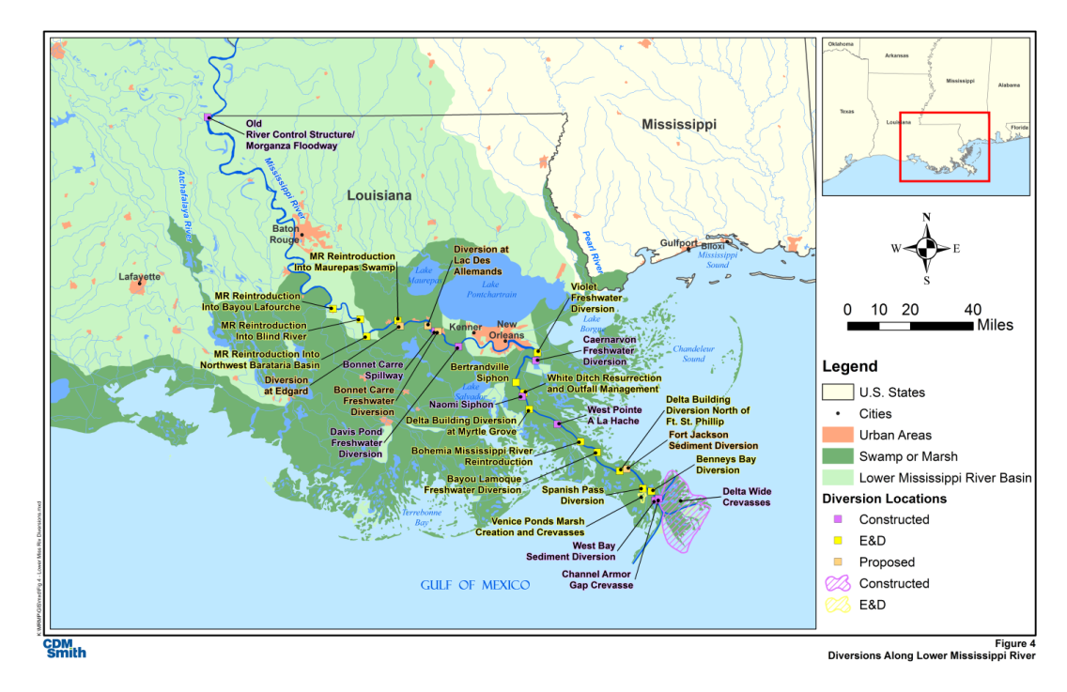
The Blind River Freshwater Diversion project is one of several ecosystem restoration projects planned by the Louisiana Coastal Protection and Restoration Authority (CPRA) and United States Army Corps of Engineers (USACE) to reintroduce freshwater, sediment, and nutrients from the Mississippi River to nearby coastal swamp systems (e.g., the Maurepas Swamp and Blind River). The Blind River is a state designated Scenic River and the project area is approximately 36 square miles (93.2 square kilometers) and almost wholly located within the Maurepas Swamp Wildlife Management Area (Figures 1, 2 and 3).

Figure 1. Coastal Louisiana Restoration Projects
Coastal Louisiana has long been a productive fishery and navigation and shipping hub. The Flood Control Act of 1928 authorized the USACE to design and construct flood control levees along the Mississippi River, which supported agricultural, industrial, commercial, and residential development along the River.
The Mississippi River flood control levees have isolated coastal wetland systems from the river and its beneficial effects of sediment and freshwater distribution for swamp regeneration and to offset subsidence and saltwater intrusion. In addition, drainage networks and associated levees have segmented wetland areas creating zones of stagnant water and low dissolved oxygen, and causing fish kills.
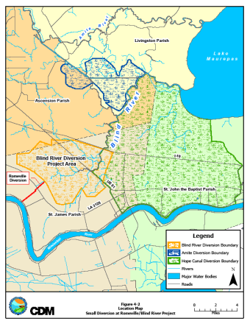
The objectives of the project are to promote water distribution in the swamp and improve water quality, establish hydroperiod fluctuation to improve productivity of bald cypress and tupelo, rebuild wetlands at a rate greater than the subsidence rate, improve biological productivity, and contribute to the protection of vital socioeconomic resources and flood protection.
The project feasibility study included an Environmental Impact Statement (EIS) and conceptual design of the diversion, transition and distribution facilities. The diversion facilities will be a gated culvert system from the Mississippi River through the flood control levee near Romeville to the transmission facilities to transport water 2 to 3 miles (3.2 to 4.8 kilometers) from the levee to distribution facilities, which discharge water throughout the swamp (i.e., via earthen channels, gravity flow culverts, and gated control structures on existing channels). Project tasks included:
Figure 2. Blind River and Maurepas Swamp Restoration Area
- Data collection and evaluation: high resolution aerial photogrammetry, ground surveys and monitoring of stage, velocity, flow and water quality
- Hydrologic (Hydrologic Engineering Center Hydrologic Modeling System - HEC-HMS), hydraulic (HEC River Analysis System RAS) for one continuous year and for design storms
- Hydrodynamic and water quality modeling (Environmental Fluid Dynamics Code - EFDC)
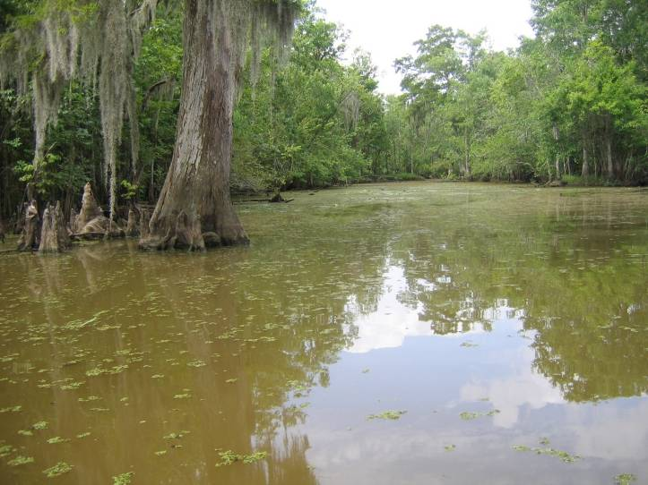
- Geotechnical data and analysis
Figure 3. Blind River
- Biological assessments and wetland value assessment (WVA) in coordination with the U.S. Fish and Wildlife Service
- Cultural and recreational surveys
- Real estate and right-of-entry evaluation
- 404b evaluation
- Coastal zone consistency determination
- Conceptual design of gated culverts, siphon, and pump options for the River diversion; transmission channel and culverts; and distribution system with berm cuts and dual use of the flood control network with gates
- Potential sea level rise and tidal backflow and surge impacts.
USACE National Research Council (NRC) sea level rise guidance was applied for three scenarios—low, medium, and high over the 50-year design life and the project provides benefits for all three cases in varying degrees. HEC-HMS and dynamic HEC-RAS models were applied for a continuous simulation year to evaluate system interconnected hydraulics and tidal effects as well as for various design storms.
The integrated stormwater conversion of the existing flood control system to a dual use distribution and flood control system will save nearly 1 square mile of forested wetland and capital costs and life cycle operation and maintenance (O&M) costs while enhancing system water distribution efficiency.
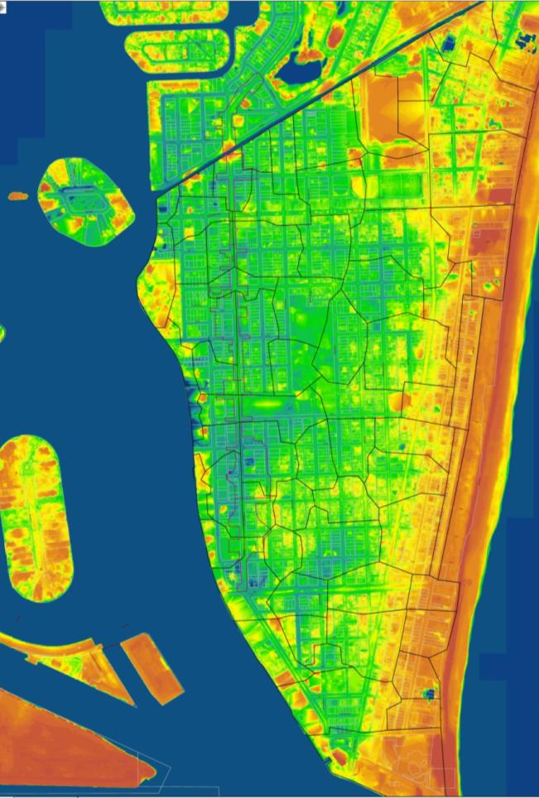
The project will redirect up to 3,000 cubic feet per second (cfs) (85 cubic meters per second – cms) of freshwater flows, increase distribution and flushing of dead zones (low dissolved oxygen with fish kills), reintroduce sediment for swamp building and habitat, and reduce saltwater intrusion and tidal backflow. Additional water quality benefits of the overall program would be to reduce discharges of nutrients to the Gulf of Mexico, which experiences an anoxic zone that varies in size from approximately 5,000 to 8,500 square miles (NOAA 2013) (12,950 to 22,015 square kilometers).
Figure 4. South Beach Topography
MIAMI BEACH
The city of Miami Beach is a South Florida coastal community in a subtropical climate surrounded by sensitive receiving waters: the Atlantic Ocean and the Biscayne Bay Aquatic Preserve. The city updated its Stormwater Master Plan (SWMP) in 2012 (CDM Smith, 2012) , and climate change resiliency was an important factor in the city’s planning decisions for stormwater infrastructure improvements to address rainfall and tidal flooding, water quality, operation and maintenance, and longer term water supply challenges.
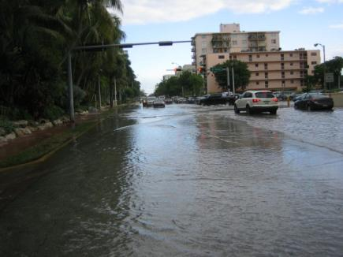
Due to its coastal location, low elevation, built-out urbanization, aging stormwater infrastructure and tidal influence (Figure 4), Miami Beach is especially impacted by:
Figure 5. October 2010 Tidal
Flooding Along Alton Road
- High tide conditions and backflow (Figure 5)
- Tropical storm flooding
- Climate change impacts, such as sea level rise and increased storm frequency and intensity
Due to these issues and more restrictive state and federal water quality regulations, the city decided to take an integrated approach to stormwater to store, recharge, harvest, and reuse stormwater to reduce pumping while protecting and improving water quality. The city’s goals for the SWMP update included:
- Protect public safety and infrastructure from flooding
- Preserve environmental and wetland resources
- Protect and improve water quality
- Provide aquifer recharge where practicable to protect and enhance existing and potential future water supplies
- Support harvesting and reuse of stormwater
- Facilitate operation and maintenance
- Provide and support long term financing
The SWMP presents sustainable stormwater management strategies with design criteria to cost-effectively achieve flood control levels of service, provide retrofit water quality treatment, and increase aquifer recharge and harvesting of stormwater for irrigation. Potential ranges of sea level rise and recently adopted numeric nutrient criteria have been included to identify solutions for both present and future conditions (e.g., 20 to 50 years – Figure 6).
Figure 6. Historic and Projected Mean High Water Levels at Virginia Key
The stormwater master plan framework is built upon the concept of a Best Management Practice (BMP) treatment train and city-wide stormwater quantity and quality models US EPA SWMM and Watershed Management Model (WMM), which were developed to provide guidance for ongoing and future design projects, consider changing environmental conditions, and account for potential ranges of climate change impacts. Conventional drainage strategies of increased conveyance and discharge (i.e., bigger pipes and pumps) are not cost-effective, would not protect the city’s aquatic natural resources, and do not comply with existing and evolving environmental and stormwater regulations. Tidal flooding is an issue as well with some low lying roads at 0.5 ft referenced to North American Vertical Datum (ft-NAVD) (0.15 meters) and tide levels ranging to 1.5 ft-NAVD (0.46 meters) in an average year.
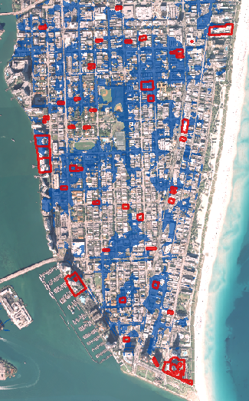
The primary purposes of Level of Service (LOS) criteria are to protect public safety and property. Program goals are to maintain passable roads for emergency and evacuation traffic, and control flood stages below homes and buildings as practicable. The LOS criteria are first used to identify and define potential problem areas using the stormwater model developed for this study. Figure 7 shows an example of the flood inundation for the 5-year design storm. The LOS criteria are then used to evaluate the effectiveness of improvements. LOS decisions will directly affect the size and cost of proposed improvement alternatives.
Figure 7. 5-Year Storm Event Flooding With Flooding Reports Identified in Red
As discussed, the city experiences significant tidal effects, and for this SWMP, the joint effects of rainfall and tides on a 20-year planning horizon on flooding and LOS were evaluated, as well as projected future sea level rise on a 50-year planning horizon for seawall heights. USACE NRC curves were applied for the sea level rise scenarios.
A tiered BMP treatment train approach (Figure 8) was used to identify the most effective solutions for each project area and to identify multi-benefit opportunities for flood control, water quality, aquifer recharge, and stormwater harvesting and irrigation use. The tiered approaches were incrementally identified from 1 through 4 and bundled together to determine the economic feasibility of proposed infrastructure improvements.
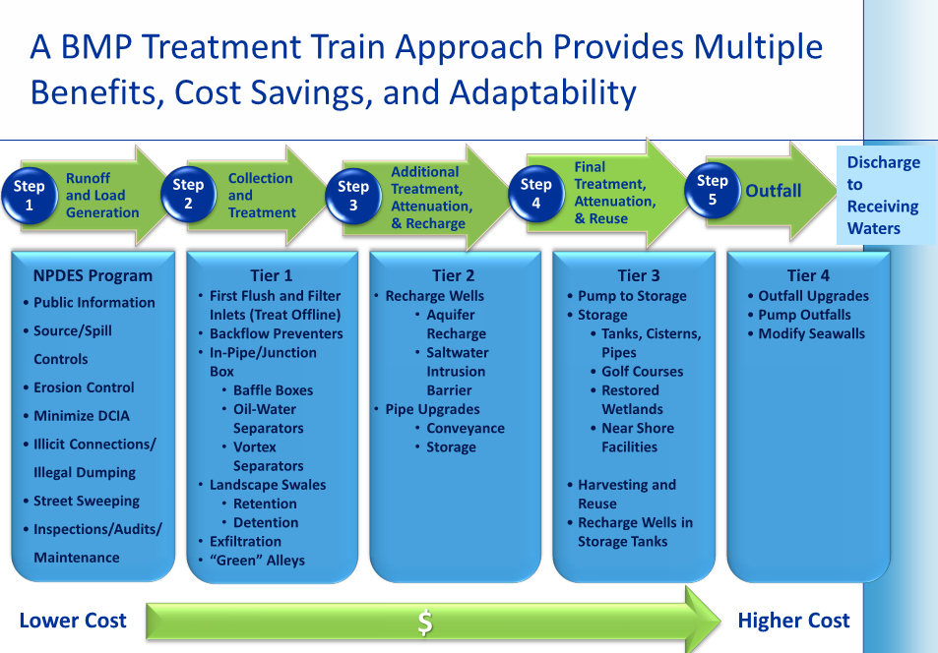
Figure 8. Tiered BMP Treatment Train Approach

Due to the anticipated significant capital investment, and the stringent permitting requirements to discharge into the Biscayne Bay, the city requested CDM Smith to present the alternative solutions in a tiered manner that would allow the city to proceed with specific elements of the BMP treatment train as economic conditions permit allowing for future tiered additions to ultimately meet the 5-year design storm LOS. Furthermore, the tiered approach minimizes the footprint and size of structural solutions in a city where urban development does not allow for land intensive BMPs such as swales, ditches, and detention facilities commonly used in Florida.
The SWMP includes:
- Landscape capture for harvesting (e.g., landscape and standard grassed swales, bioretention, green alleys, and rain gardens)
- Recharge wells (gravity as possible)
- Exfiltration systems
- Outfall backflow preventers
- Storage in ponds and tanks (e.g., cisterns, park bleachers, under parking lots) for treatment, flood and pump rate attenuation, harvesting, and reuse
- New pump stations to achieve flood control goals while protecting and improving water quality
Seawall recommendations are also included for coastal armoring and will need to be implemented while protecting sensitive seagrass areas along the islands in the Biscayne Bay Aquatic Preserve. City parks will consider incorporation of underground and in-bleacher tank systems as cisterns and wet wells for pumps allowing irrigation with stormwater. This would reduce potable demand, extending existing water supplies and reducing the volume of stormwater that must be pumped (along with operational costs) while providing flood control and reduced pollutant loads to sensitive receiving waters. City stormwater, sewer, water, and park projects are being coordinated with Florida Department of Transportation (FDOT) transportation projects to leverage funding and save costs where possible (e.g., Alton Road on South Beach).
The capital improvements program (CIP) identified in the SWMP is approximately $210 million for the city’s primary stormwater management system (PSMS), plus associated Operation and Maintenance (O&M) costs for the 20 year stormwater facility planning horizon. The recommended infrastructure improvements—including storing and treating stormwater through merging neighborhood park/street/landscape improvement projects with stormwater retention-detention elements, exfiltration, irrigation systems and recharge wells—provide management strategies that cost-effectively address tidal conditions, flooding and regulatory- defined water quality requirements. They also provide water sources for park irrigation and long-term saltwater intrusion barriers.
Proposed coastal protection strategies for tidal intrusion and flooding are coordinated with the BMP treatment train process and consider potential ranges of climate change from USACE civil works guidance. These include seawall enhancements; increased stormwater storage, harvesting, and recharge; and backflow prevention devices to account for anticipated sea level increases over the next 20 to 50 years, with adaptive approaches that are consistent with the BMP treatment train (e.g., greater stormwater storage and recharge along with increased harvesting and reuse of stormwater for irrigation and saltwater intrusion barriers). Long term opportunities may be available for recovery of stormwater aquifer recharge over the initial 20 year implementation period.
SUMMARY AND CONCLUSIONS
These projects contrast urban and natural system approaches to sustainable and resilient solutions to address program goals, climate change factors, and coastal waters protection. It can be done.
The Blind River Freshwater Diversion project presents restoration approaches to improve water quality, flora, and fauna for coastal systems and waters experiencing saltwater intrusion and high levels of nutrients at the Mississippi River outlet to the Gulf of Mexico. The project will redirect flows from the Mississippi River as one of several projects to restore the sediment, beneficial nutrient, and freshwater flux to these systems to improve water quality, offset subsidence, and counterbalance saltwater intrusion and sea level rise.
The Miami Beach SWMP presents sustainable coastal stormwater management strategies in a BMP treatment train with design criteria to cost-effectively achieve flood control levels of service, provide retrofit water quality treatment, and increase aquifer recharge and harvesting of stormwater for irrigation. Potential ranges of sea level rise and pending numeric nutrient criteria have been included to identify solutions for both present and future conditions (e.g., 20 to 50 years).
REFERENCES
CDM Smith, Blind River Freshwater Diversion Project Feasibility Study and Environmental Impact Statement, 2008.
CDM Smith, City of Miami Beach Stormwater Master Plan, 2012.
Louisiana Coastal Protection and Restoration Authority, Draft Project Management Plan Support for the Mississippi River and Coastal Management Plan (CDM Smith, 2010)
United States Army Corps of Engineers, Engineering Circular 1165-2-212, 2011.

