**Sustainable Stormwater Management for the Barrier Island Community of Miami Beach**

Michael F. Schmidt, P.E., BCEE **1\***, Richard Saltrick, P.E. **2**, Jason A. Johnson, P.E. **3**, Jose Maria Guzman, P.E., D.WRE **2**

**1** CDM Smith, Jacksonville Florida

**2** City of Miami Beach, Florida

**3** CDM Smith, Miami Florida

**\*** Email: [schmidtmf@cdmsmith.com](mailto:schmidtmf@cdmsmith.com)

**Abstract**

In 2010, the City of Miami Beach commenced a comprehensive stormwater master plan (SWMP) update and development of stormwater design criteria with the objectives of identifying sustainable short- and long-term stormwater management solutions that protect public safety and the City’s infrastructure, preserve the City’s environmental resources, and enhance the residents' quality of life.

The SWMP presents sustainable strategies in a best management practice (BMP) treatment train with design criteria to cost-effectively achieve flood control levels of service, provide retrofit water quality treatment, and increase aquifer recharge and harvesting of stormwater for irrigation. Potential ranges of sea level rise and pending numeric nutrient criteria have been included to identify solutions for both present and future conditions (e.g., 20 to 50 years).

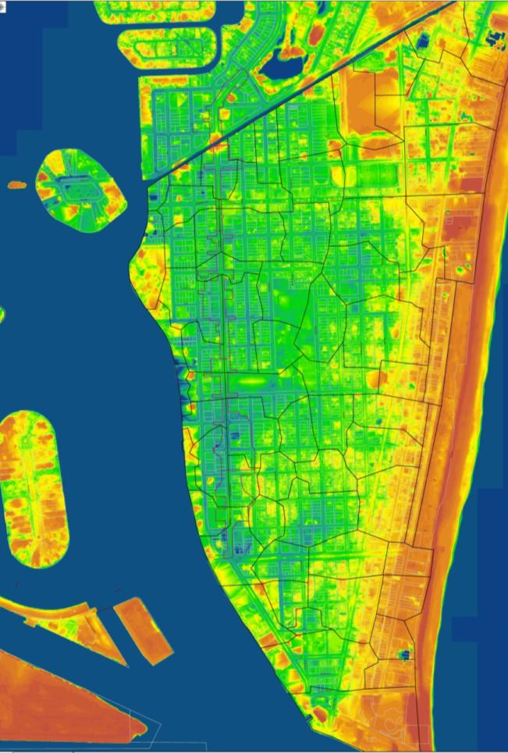**Key Words:** Best Management Practice (BMP) Treatment Train, water quality, sea level rise, recharge wells, exfiltration, first flush systems, backflow preventers, sea walls, level of service.

**The Problem and Challenge**

The City of Miami Beach, Florida, is a barrier island with its world famous beach, surrounded by sensitive receiving waters: the Atlantic Ocean and the Biscayne Bay Aquatic Preserve. Due to its coastal location, low elevation, built-out urbanization, aging stormwater infrastructure and tidal influence, Miami Beach is especially vulnerable to high tide conditions; tropical storm flooding; and climate change impacts, such as sea level rise and increased storm frequency and intensity. These issues, coupled with more restrictive state and federal water quality regulations, are requiring the City to revisit historic strategies of increased conveyance and pumping for stormwater management.

Figure 1 – South Beach Topography Varies From 0 to 12 ft Above Sea Level

**Goals and Objectives**

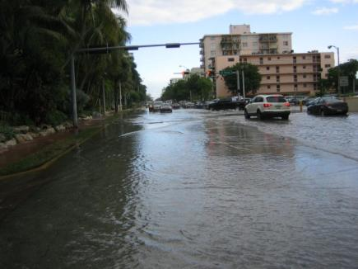In 2010, the City commenced a comprehensive stormwater master plan (SWMP) update and development of stormwater design criteria with the following goals to achieve sustainable stormwater management solutions:

* Protect infrastructure from flooding;
* Preserve environmental and wetland resources;
* Protect and improve water quality;
* Provide aquifer recharge where practicable to protect and enhance existing and potential future water supplies;

Figure 2 – October 2010 Tidal Flooding Along Alton Road

* Support harvesting and reuse of stormwater;
* 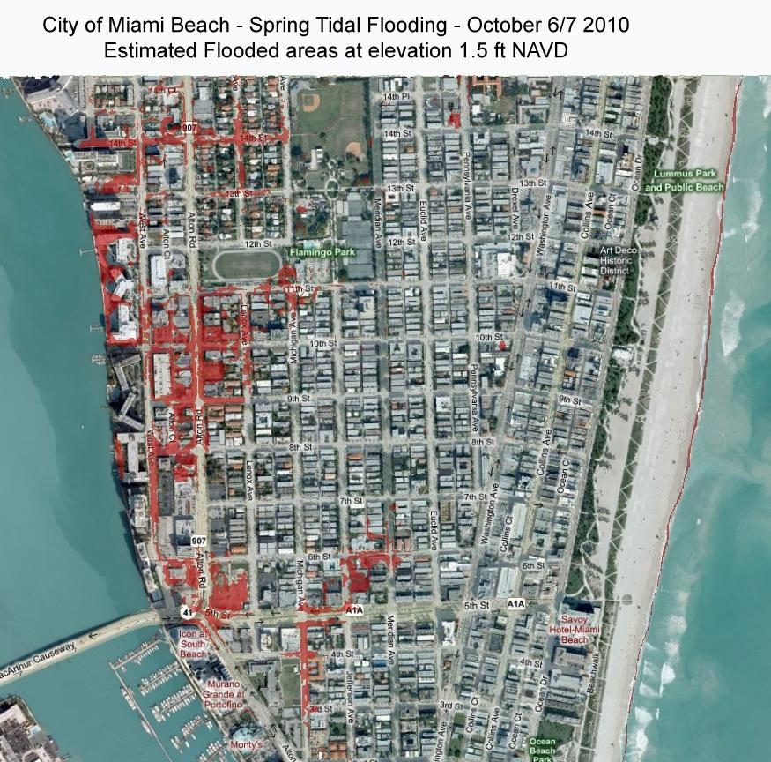Facilitate operation and maintenance; and
* Provide and support long term financing.

The SWMP presents sustainable stormwater management strategies with design criteria to cost-effectively achieve flood control levels of service, provide retrofit water quality treatment, and increase aquifer recharge and harvesting of stormwater for irrigation. Potential ranges of sea level rise and pending numeric nutrient criteria have been included to identify solutions for both present and future conditions (e.g., 20 to 50 years).

**Approach**

The stormwater master plan framework is built upon the concept of a BMP treatment train and City-wide stormwater models, which were developed to provide guidance for ongoing and future design projects, consider changing environmental conditions, and account for potential ranges of climate change impacts. Conventional drainage strategies of increased conveyance and discharge (i.e., bigger pipes and pumps) are not cost-effective, would not protect the city’s aquatic natural resources, and do not comply with existing and evolving environmental and stormwater regulations. Tidal flooding is an issue as well with some low lying roads at 0.5 ft-NAVD and tide levels ranging to 1.5 ft-NAVD in an average year.

Figure 3 – October 2010 Tidal Flooding at Elevation 1.5 ft NAVD

## Methodology

As part of this SWMP, surface water hydrologic and hydraulic modeling has been performed using the US EPA Storm Water Management Model (SWMM) to estimate and evaluate flooding LOS and alternative solutions to meet LOS. The process for performing surface water quality and BMP evaluations using the CDM Smith Watershed Management Model (WMM) was used to perform surface water quality and BMP evaluations. Both are public domain tools that are widely used for SWMP applications.

As a complement to the engineering evaluation, CDM Smith utilized the FEMA Hazards United States (HAZUS) tool designed to produce loss estimates for use by federal, state, regional and local governments and private enterprises in planning for risk mitigation, emergency preparedness, response and recovery.

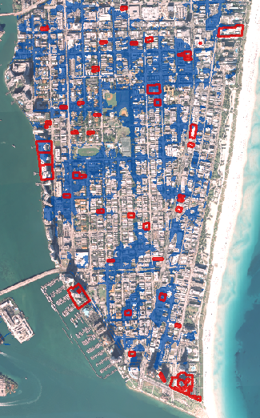Model parameter estimates were checked for validity during actual storm and tidal events throughout the year 2010, as practical. Investigations including photo-archive retrievals, field visits, photography in combination with flood depth measurements and discussions with City staff were performed as part of the validation stage. Storm event rainfall data was retrieved from City of Miami Beach rain gages and tidal data retrieved from National Oceanic and Atmospheric Administration (NOAA).

## Level of Service (LOS)

The primary purposes of LOS criteria are to protect public safety and property. Program goals are to maintain passable roads for emergency and evacuation traffic, and control flood stages below homes and buildings as practicable. The LOS criteria are first used to identify and define potential problem areas using the stormwater model developed for this study. The LOS criteria are then used to evaluate the effectiveness of improvements. LOS decisions will directly affect the size and cost of proposed improvement alternatives.

CDM Smith evaluated refinements of the current LOS standard as part of the evaluation of the SWMP. The 5-year, 24-hour (5.9 inches) event was eventually evaluated as the critical event to evaluate stormwater system performance. As a test of system performance and for cost-benefit comparisons, CDM also evaluated LOS for the 2-year 24-hour (4.2 inches), the 10- (9.9 inches), 25- (11 inches), and 100- year 72-hour (14 inches) design storms. LOS evaluations were made for road gutter-crown and building elevations where data were available. Meeting the LOS for the SWMP is defined by maximum level of flooding up to the 6-inches above the roadway gutter elevation during the 5-year 24-hour storm event.

Figure 4 - 5 Year Storm Event Flooding With Flooding Reports Identified in Red

The City also experiences significant tidal effects, and for this SWMP, CDM evaluated the joint effects of rainfall and tides on flooding and LOS as well as projected future sea level rise on a 50 year planning horizon.

Proposed Improvements and Project Coordination

Evaluations were performed for project areas to determine the level of infrastructure improvements necessary to meet the 2-year (4.2 inches) and 5-year (5.9 inches) LOS. A tiered BMP treatment train approach was used to identify the most effective solutions for each project area (**Figure 4**) and to identify multi-benefit opportunities for flood control, water quality, aquifer recharge, and stormwater harvesting and irrigation use. The tiered approaches were incrementally identified from 1 through 4 and bundled together to determine the economic feasibility of proposed infrastructure improvements. Due to the anticipated significant capital investment, and the stringent permit to discharge into the Biscayne Bay, the City requested CDM Smith to present the alternative solutions in a tiered manner that would allow the City to proceed with specific elements of the BMP treatment train as economic conditions permit allowing for future tiered additions to ultimately meet the full 5-year LOS. Furthermore the tiered approach minimizes the footprint and size of structural solutions, in a city where urban development does not allow for land intensive BMPs such as swales, ditches and detention facilities commonly used in Florida.

Figure 5 BMP Treatment Train

## Project Ranking and Recommendations

The results of the flood damage analysis using the HAZUS tool show that the existing conditions in Miami Beach have significant potential economic losses associated with flood events for both rainfall and tidal flood sources.

In South Beach alone, rainfall flood events have potential losses (residential and non-residential damage to structures, including contents) that range from $10.5 million for the 3.4-inch (1-year 24-hour) storm up to $49.7 million for the 14-inch (100-year 72-hour) storm.

CDM Smith and the City developed a prioritized stormwater Capital Improvement Program (CIP) list based on the ongoing projects and problem areas identified in the SWMP. In addition, CDM Smith provided recommendations regarding overall stormwater management needs to achieve better operation and maintenance, policies, and standards for existing and future conditions.

Three project categories have been identified:

* Early Out Projects and Scheduled CIP Projects;
* Concurrency-Reviewed CIP Projects; and
* SWMP- Identified Projects.

The CIP identified in the SWMP are approximately $200 million in capital improvements proposed for the City’s primary stormwater management system, plus associated Operation and Maintenance (O&M) costs. The proposed projects include a combination of the elements shown in Figure 5, in consistency with the proposed tiered approach.

**SUMMARY AND CONCLUSIONS**

The recommended infrastructure improvements—including storing and treating stormwater through merging neighborhood park/street/landscape improvement projects with stormwater retention-detention elements, exfiltration, irrigation systems and recharge wells—provide management strategies that cost-effectively address tidal conditions, flooding and regulatory- defined water quality requirements. They also provide water sources for park irrigation and long-term saltwater intrusion barriers.

Proposed coastal protection strategies for tidal intrusion and flooding are coordinated with the BMP treatment train process and consider potential ranges of climate change from United States Army Corps of Engineers (USACE) civil works guidance. These include seawall enhancements; increased stormwater storage, harvesting, and recharge; and backflow prevention devices to account for anticipated sea level increases over the next 20 to 50 years, with adaptive approaches that are consistent with the BMP treatment train (e.g., greater stormwater storage and recharge along with increased harvesting and reuse of stormwater for irrigation and saltwater intrusion barriers).

The City has developed a sustainable stormwater management plan that considers sea level rise and addresses flooding, water quality, aquifer recharge, and coordination with other public infrastructure including parks, utilities, and FDOT roadways. The plan provides the City’s desired flood control levels of service while providing retrofit treatment consistent with current and pending regulations, harvesting of stormwater for park irrigation, and aquifer recharge to reduce freshwater and nutrient discharges, reduce saltwater intrusion, and possibly provide a source of water in the future.

The SWMP was completed in December 2011. The BMP treatment train has been incorporated into all ongoing and future stormwater improvement projects and is being coordinated with FDOT roadways improvements, as well as City park and golf course improvements. Stormwater design criteria were developed for inclusion in the various utility design criteria packages, inclusive of landscaping, water, sewer, roadway and park improvements. Implementation is ongoing.

**ACKNOWLEDGEMENTS**

The authors gratefully acknowledge the City of Miami Beach and the City Commission for their support of this project.

**REFERENCES**

CDM Smith, *Miami-Dade County Aviation Department* *Miami International Airport Stormwater Master Plan,* 1992

Federal Emergency Management Agency (FEMA) *Hazard US (HAZUS) Tool*, 2010

Florida Department of Environmental Protection (FDEP) *Land Development Procedures Manual – BMP Treatment Train,* 1986

FDEP *Chapter 62-528 Florida Administrative Code Underground Injection Control*

South Florida Water Management District (SFWMD) *Chapter 40E-4 Florida Administrative Code*

United States Army Corps of Engineers *Engineering Circular EC1165‐2‐211 Water Resource Policies and Authorities Incorporating Sea-Level Change Considerations in Civil Works Programs* (July 2009).